**United States Department of Agriculture**

Food and Nutrition Service

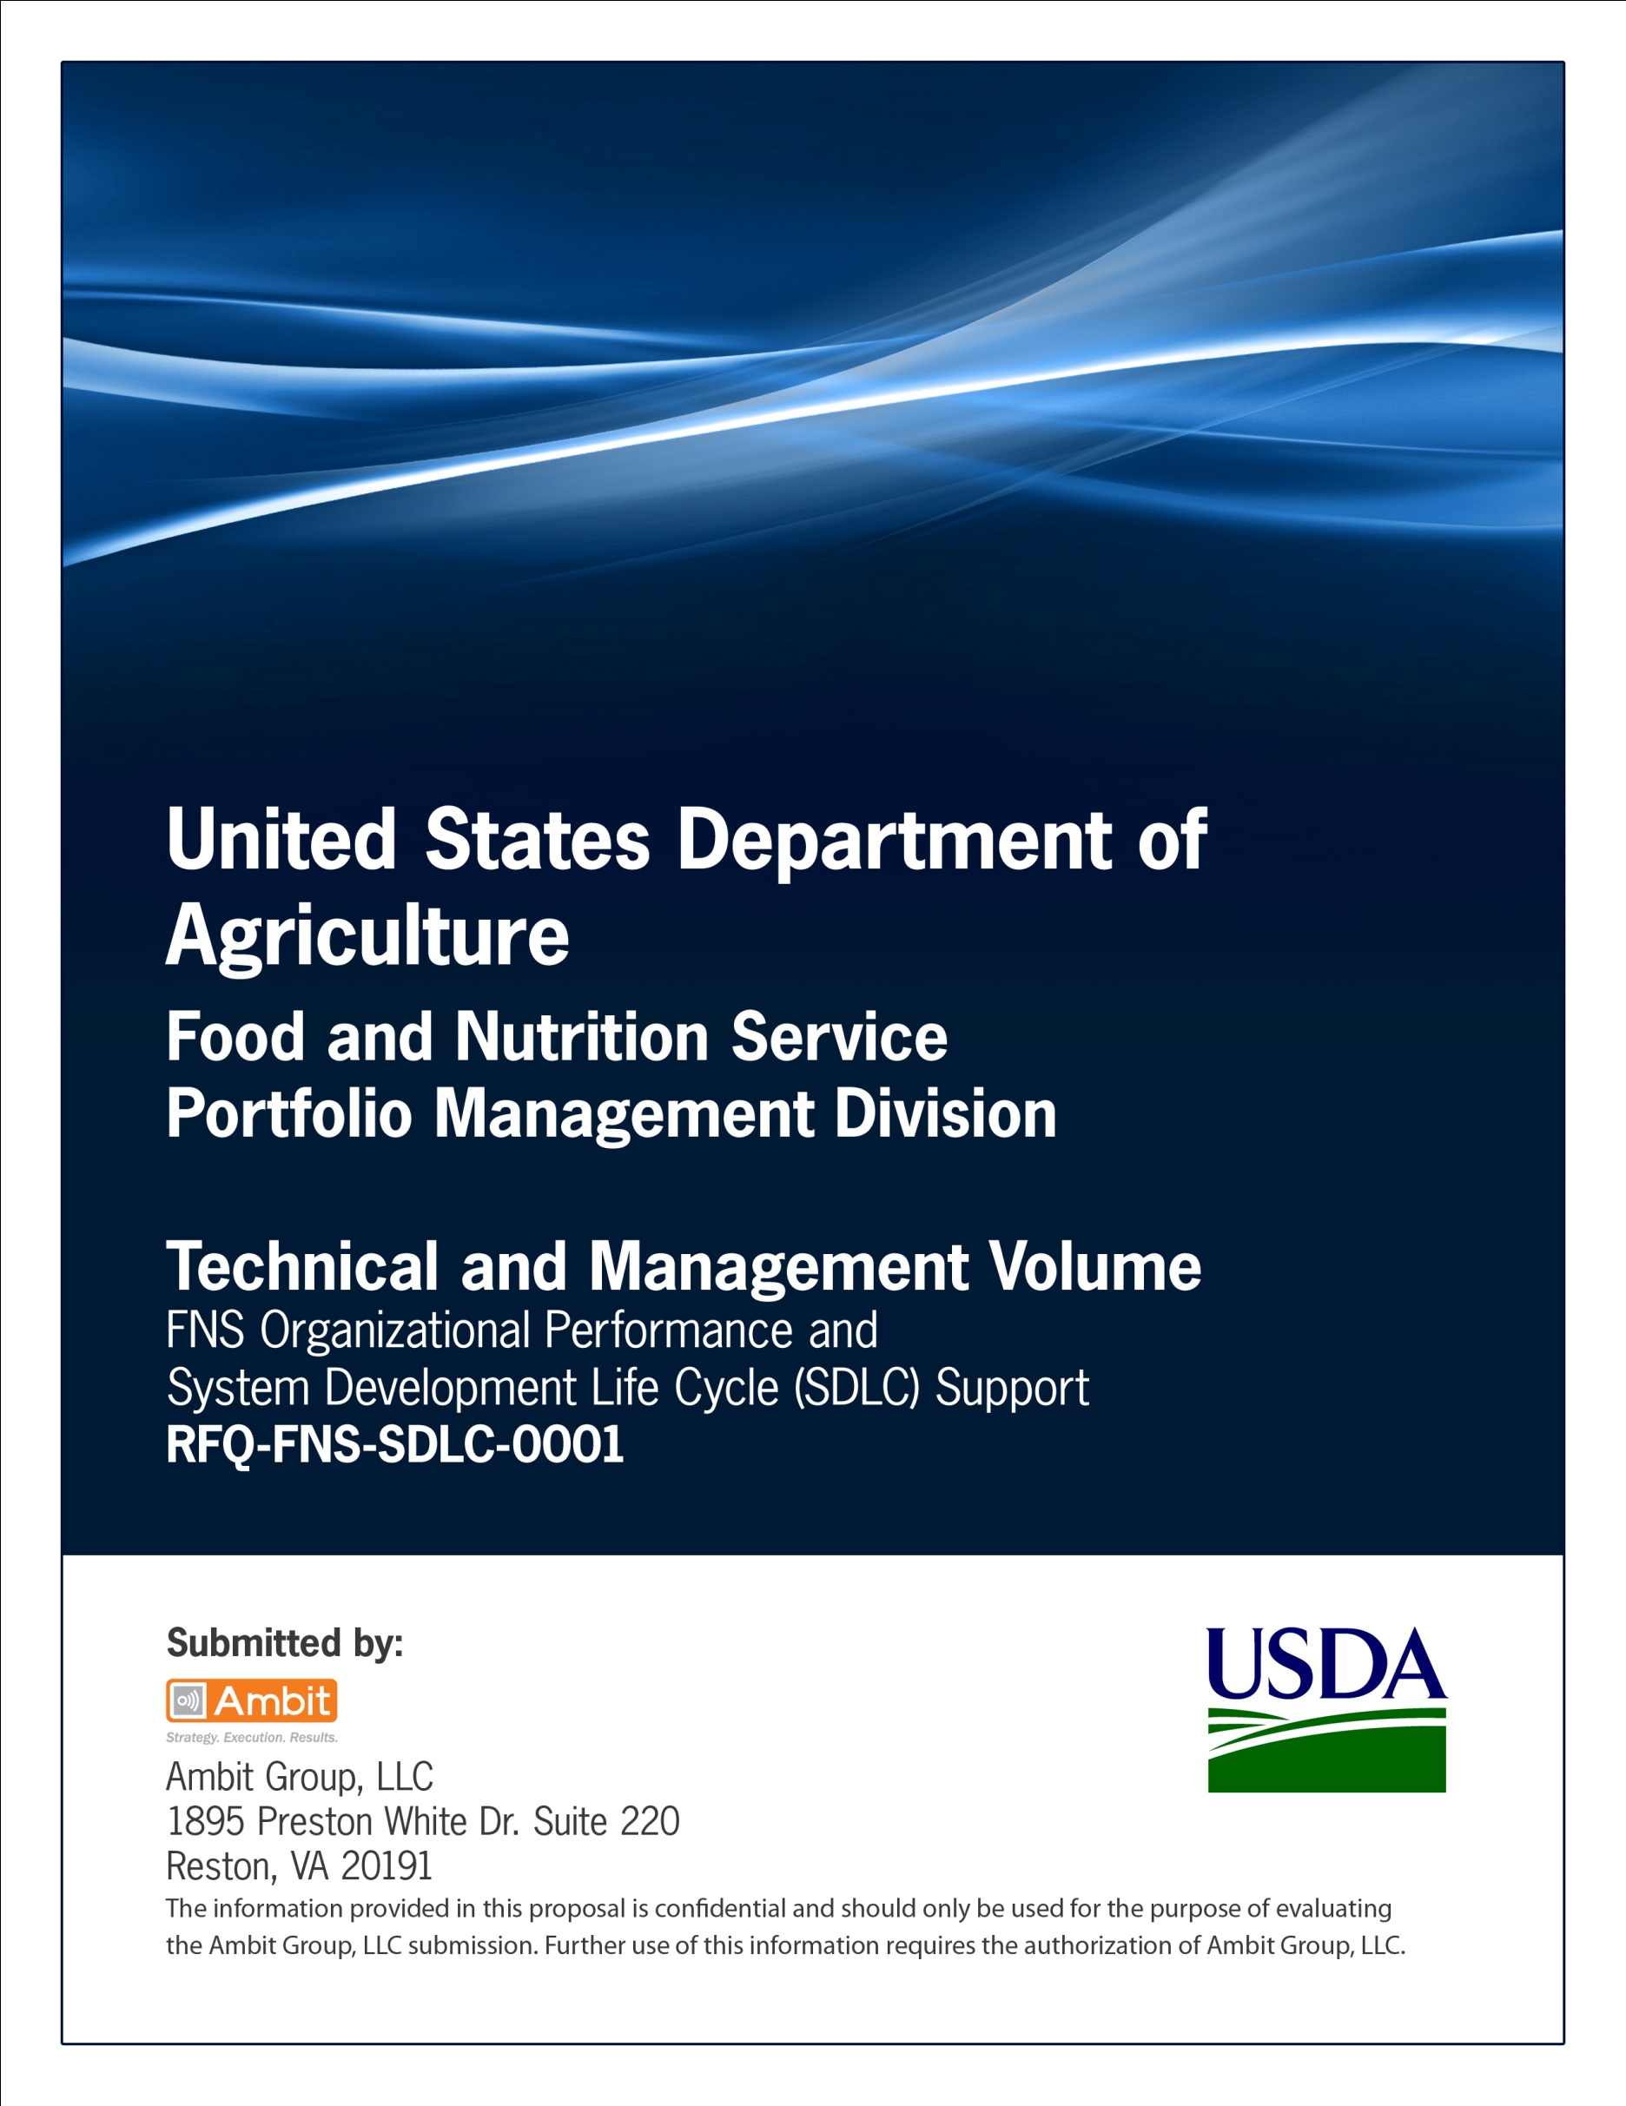

**FNS Office of Information Technology**

**Portfolio Management Division (PMD)**

**FNS Concept of Operations Template**

**for**

**[Project or System Name]**

**Version 1.1**

September 09, 2013

**Revision History**

|  |  |  |  |
| --- | --- | --- | --- |
| **Version** | **Date** | **Author** | **Change Description** |
| 1.0 | 03-19-2013 | IT Governance Branch (ITGB) | Created the document. |
| 1.1 | 09-09-2013 | IT Governance Branch (ITGB) | Re-formatted the document. |
| 1.2 |  |  |  |
| 1.3 |  |  |  |

**Contact Information**

|  |  |
| --- | --- |
| **Area of Concern** | **Contact Person** |
| IT Governance Lead | Kevin Russ |
| SDLC Coordinator | Syed Jaffery |
| ITIRB Coordinator | Sunny Dilawari |
| Portfolio Management Division Director, Chief Portfolio Officer | Jacqueline Butler |
| Program Management Branch Chief | Allison Willcox |

Contents

Glossary 4

1. Introduction 5

2. Scope 6

2.1. Identification 6

2.2. System Overview 6

2.3. Document Overview 6

2.4. Document References 6

3. Current System or Situation 6

3.1. Background, Objectives, and Scope 6

3.2. Operational Policies and Constraints 6

3.3. Description/Purpose 6

3.4. Description of Current System or Situation 7

3.5. Users or Involved Personnel 7

4. Justification For and Nature of Changes 7

4.1. Justification for Change 7

4.2. Description of Needed Changes 7

4.3. Priorities among the Changes 8

4.4. Assumptions, Dependencies, Constraints 8

5. Concept for a New or Modified System 8

5.1. Background, Objectives, and Scope 8

5.2. Operational Policies and Constraints 8

5.3. Description of New or Modified System 8

5.4. Users or Affected Personnel 8

5.5. Support Strategy 9

6. Operational Scenarios 9

7. Summary of Impacts 9

7.1. Operational Impacts 9

7.2. Organizational Impacts 9

7.3. Impacts During Development 9

8. Analysis of Proposed System 10

8.1. Summary of Advantages 10

8.2. Summary of Disadvantages/Limitations 10

8.3. Alternatives and Trade-offs Considered 10

9. Security Requirements 10

10. Assumptions, Constraints, Pre-Requisites, Authority, Responsibilities 10

Appendix A: References 11

Approvals/Signatures 12

# Glossary

| **Acronym** | **Description** |
| --- | --- |
|  |  |
|  |  |
|  |  |
|  |  |
|  |  |
|  |  |
|  |  |
|  |  |

# Introduction

This template provides recommended technical content for concept of operations documentation. This document is not a mandatory life cycle document. However, it is useful during project initiation as a place to capture/document pre-project initiation, pre-vendor selection and pre-COTS (computer-off-the-shelf) selection data pending project approval by the appropriate authority. The concept of operations document can be viewed as a convenient place to accumulate pre-requirements project data and can be used to obtain consensus among the user and developer (and other stakeholders). Depending on its use, this document may focus on communicating the user's needs to the developer or the developer's ideas to the user and other interested parties.

# Scope

This section provides a general overview of the system written in non-technical terminology. The summary should outline the uses of the system in supporting the activities of the user and staff.

## Identification

This section contains a full identification of the system to which this document applies, including, as applicable, identification number(s), title(s), abbreviations), version number(s), and release number(s).

## System Overview

This section shall briefly state the purpose of the system to which this document applies. It shall describe the general nature of the system; summarize the history of system development, operation, and maintenance; identify the project sponsor, acquirer, user, developer, and maintenance organizations; identify current and planned operating sites; and list other relevant documents.

## Document Overview

This section shall summarize the purpose and contents of this document and shall describe any security or privacy protection considerations associated with its use.

## Document References

List the publisher, document identification number, title, revision, and date of all documentation referenced in the ConOps document. This section should also identify a contact for all documents not available through normal channels.

# Current System or Situation

This section and subsections describe about the Current System.

## Background, Objectives, and Scope

This section shall describe the background, mission or objectives, and scope of the current system or situation.

## Operational Policies and Constraints

This shall describe any operational policies and constraints that apply to the current system or situation.

## Description/Purpose

Describes the product/system in terms of the user needs it will fulfill, its relationship to existing systems or procedures, and the ways it will be used.

## Description of Current System or Situation

This shall provide a description of the current system or situation, identifying differences associated with different states or modes of operation (for example, regular, maintenance, training, emergency, and alternative-site). The distinction between states and modes is arbitrary. A system may be described in terms of states only, modes only, states within modes, modes within states, or any other scheme that is useful. If the system operates without states or modes, this shall so state, without the need to create artificial distinctions. The description shall include, as applicable:

* The operational environment and its characteristics
* Major system components and the interconnections among these components
* Interfaces to external systems or procedures
* Capabilities/functions of the current system
* Charts and accompanying descriptions depicting input, output, data flow, and manual and automated processes sufficient to understand the current system or situation from the user's point of view
* Performance characteristics, such as speed, throughput, volume, frequency
* Quality attributes, such as reliability, maintainability, availability, flexibility, portability, usability, efficiency
* Provisions for safety, security, privacy protection, and continuity of operations in emergencies

## Users or Involved Personnel

This section shall describe the types of users of the system, or personnel involved in the current situation, including, as applicable, organizational structures, training/skills, responsibilities, activities, and interactions with one another.

This section shall also provide an overview of the support strategy for the current system, including, as applicable to this document, maintenance organizations; facilities; equipment; maintenance software; repair/replacement criteria; maintenance levels and cycles; and storage, distribution, and supply methods.

# Justification For and Nature of Changes

This section provides the justification for the nature of changes in the system.

## Justification for Change

This subsection shall describe new or modified aspects of user needs, threats, missions, objectives, environments, interfaces, personnel or other factors that require a new or modified system. This should also summarize deficiencies or limitations in the current system or situation that makes it unable to respond to these factors.

## Description of Needed Changes

This subsection shall summarize new or modified capabilities/functions, processes, interfaces, or other changes needed to respond to the factors identified above.

## Priorities among the Changes

This subsection shall identify priorities among the needed changes. It shall, for example, identify each change as essential, desirable, or optional, and prioritize the desirable and optional changes.

## Assumptions, Dependencies, Constraints

This subsection shall identify any assumptions, dependencies on other factors/projects/organizations/systems and constraints applicable to the changes identified in this clause.

# Concept for a New or Modified System

## Background, Objectives, and Scope

This subsection shall describe the background, mission or objectives, and scope of the new or modified system.

## Operational Policies and Constraints

This subsection shall describe any operational policies and constraints that apply to the new or modified system.

## Description of New or Modified System

This shall provide a description of the new or modified system, identifying differences associated with different states or modes of operation (for example, regular, maintenance, training, emergency, and alternative-site). The distinction between states and modes is arbitrary. A system may be described in terms of states only, modes only, states within modes, modes within states, or any other scheme that is useful. If the system operates without states or modes, this shall so state, without the need to create artificial distinctions.

The description shall include, as applicable:

* The operational environment and its characteristics
* Major system components and the interconnections among these components c. Interfaces to external systems or procedures
* Capabilities/functions of the new or modified system
* Charts and accompanying descriptions depicting input, output, data flow, and manual and automated processes sufficient to understand the new or modified system or situation from the user's point of view.
* Performance characteristics, such as speed, throughput, volume, frequency
* Quality attributes, such as reliability, maintainability, availability, flexibility, portability, usability, efficiency
* Provisions for safety, security, privacy protection, and continuity of operations in emergencies

## Users or Affected Personnel

This subsection shall describe the types of users of the new or modified system, including, as applicable, organizational structures, training/skills, responsibilities, and interactions with one another.

## Support Strategy

This shall provide an overview of the support strategy for the new or modified system, including, as applicable, maintenance organizations); facilities; equipment; maintenance software; repair/replacement criteria; maintenance levels and cycles; and storage, distribution, and supply methods.

# Operational Scenarios

This section shall describe one or more operational scenarios that illustrate the role of the new or modified system, its interaction with users, its interface to other systems, and all states or modes identified for the system. The scenarios shall include events, actions, process flow, stimuli, information, interactions, etc., as applicable. Reference may be made to other media, such as videos or models, to provide part or all of this information.

As an example, for a web site product development, a graphics tool such as MS VISIO could be used to generate “pictures” of all web pages associated with the new web site. Simple text could be used to describe the functional processes on each page as well as the process flow and navigation flow from page to page. These “draft” web pages could then be used as a functional requirements foundation, user interface requirements, as well as a preliminary start at the data elements that should be included in a data structure.

# Summary of Impacts

## Operational Impacts

This subsection shall describe anticipated operational impacts on the user, acquirer, developer, and maintenance organizations. These impacts may include changes in interfaces with computer operating centers; change in procedures; use of new data sources; changes in quantity, type, and timing of data to be input to the system; changes in data retention requirements; and new modes of operation based on normal or emergency conditions.

## Organizational Impacts

This subsection shall describe anticipated organizational impacts on the user, acquirer, developer, and maintenance organizations. These impacts may include modification of responsibilities; addition or elimination of responsibilities or positions; need for training or retraining; and changes in number, skill levels, position identifiers, or location of personnel in various modes of operation.

## Impacts During Development

This subsection shall describe anticipated impacts on the user, acquirer, developer, and maintenance organizations during the development effort. These impacts may include meetings/discussions regarding the new system; development or modification of databases; training; parallel operation of the new and existing systems; impacts during testing of the new system; and other activities needed to aid or monitor development.

# Analysis of Proposed System

## Summary of Advantages

This subsection shall provide a qualitative and quantitative summary of the advantages to be obtained from the new or modified system. This summary shall include new capabilities, enhanced capabilities, and improved performance, as applicable, and their relationship to deficiencies identified.

## Summary of Disadvantages/Limitations

This shall provide a qualitative and quantitative summary of disadvantages or limitations of the new or modified system. These disadvantages and limitations shall include, as applicable, degraded or missing capabilities, degraded or less-than-desired performance, greater-than-desired use of computer hardware resources, undesirable operational impacts, conflicts with user assumptions, and other constraints.

## Alternatives and Trade-offs Considered

This shall identify and describe major alternatives considered to the system or its characteristics, the trade-offs among them, and rationale for the decisions reached.

# Security Requirements

This section should contain the following:

* Purpose of the system
* Description of the system architecture
* Security authorization schedule
* Security categorization and associated factors considered in determining the categorization

# Assumptions, Constraints, Pre-Requisites, Authority, Responsibilities

This section should contain the following:

* Interface with and/or availability of other products, systems, resources, organizations.
* Technology availability
* Cost
* Schedule
* Regulations

# Appendix A: References

Insert the name, version number, description, and physical location of any documents referenced in this document. Add rows to the table as necessary.

The following table summarizes the documents referenced in this document.

|  |  |  |
| --- | --- | --- |
| **Document Name** | **Description** | **Location** |
| Document Name and Version Number | Document description | URL or Network path where document is located |
|  |  |  |
|  |  |  |

# Approvals/Signatures

The undersigned acknowledge that they have reviewed the [name of document] document and agree with the information presented within this document. Changes to this document will be coordinated with, and approved by, the undersigned, or their designated representatives.

|  |  |  |  |
| --- | --- | --- | --- |
| Signature: |  | Date: |  |
| Print Name: |  |  |  |
| Title: |  |  |  |
| Role: | [Project or System Name] Project Manager |  |  |
|  |  |  |  |
| Signature: |  | Date: |  |
| Print Name: |  |  |  |
| Title: |  |  |  |
| Role: | [Project or System Name] Business Owner |  |  |
|  |  |  |  |
| Signature: |  | Date: |  |
| Print Name: |  |  |  |
| Title: |  |  |  |
| Role: | Organization’s Approving Authority |  |  |